 Pueri
Iuvenes
Laeti
Advolant

 Saepe
Insistit
Lupus
Velox
Agnum

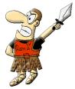 Rex
Obsidet
Multas
Urbes
Latii
Undique
Submissas

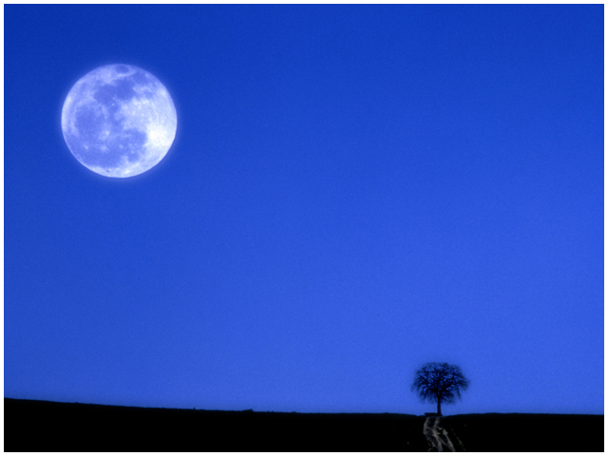 Lux
Umbratilis
Nautam
Adducit

 Splendidam
Offert
Lucem

Texta et graphica elaboratio: Gervasio Gerardo, Marena Pasquale, Mirra Orlando, Tresca Carmine Andrea.
Supervisor: Lucia Mattera

 |  | 

